Like arrays, objects can have one or more elements.

But unlike arrays, indices in objects don’t change – each value has their own reference key.

A reference key is a unique identifier that corresponds with the value.

The relationship between the items on the list is different in an object than they would be in an array.

This is because in an object each value is independent and there isn’t the need for fixed order.

Objects are associative arrays.

const artist = {

firstName: "Michael",

lastName: "Jackson",

birthYear: 1958,

numberOneHits: 13

};

Properties and Values

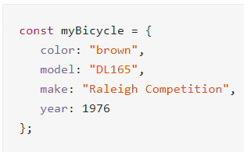

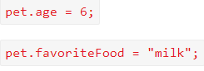

Syntax for array that contains objects.

const garden = [

{

color: 'red',

flower: 'rose',

},

{

color: 'blue',

flower: 'violet',

petals: 6

}

];